How to fill in the xls template
1 Introduction 2
2 Prerequisites 2
3 Step-by-step plan 3

Introduction
This manual is intended as guide for completing the Juniper Junos Firewall and switch template.

Prerequisites
- Firewall/switch name and type
- Microsoft Excel
- Meso privileged user

Step-by-step plan
- In Internet explorer go to http://meso.jandenul.com/meso-webtop/drl/objectId/090236ed8269fa2e and edit the file.
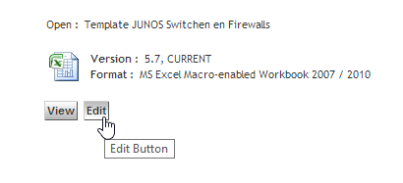
- If asked enable macros by clicking on “Enable Content”
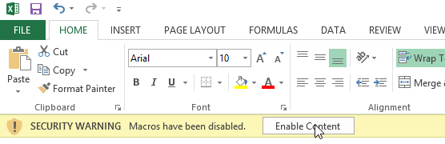
- In the “Information” tab fill in the name and abbreviation in the coresponding cells. If you are installing a Juniper SRX240H2 cluster fill the information in the first 266 rows. If you are installing a standalone SRX100 or SRX240H2 fill in the information after row 266. You can find a hyperlink to the row in cell B8.
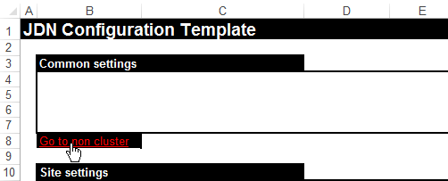
- In the “information” tab fill in the corresponding site id in cel F4 and press enter.
You can see the selected site and information in the calculated section.
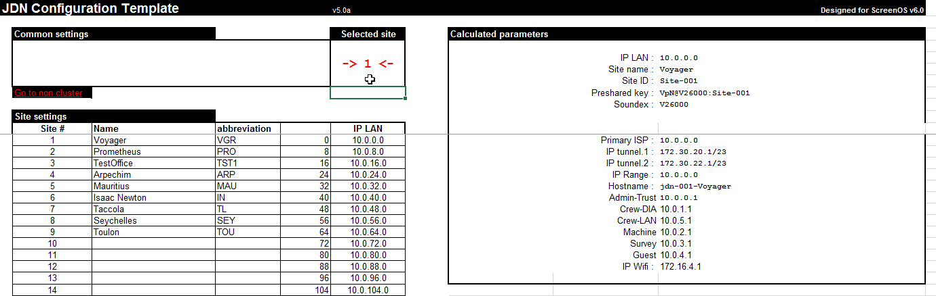

- Go to the “Overview configs” tabs and select the desired configuration.
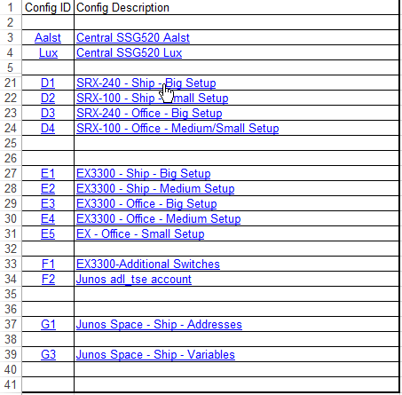

- Save the configuration of the firewall in a text file.
- In order to have a fully functional switch configuration you must have the commands from an Ex tab and “F1” tab copied in one text file.
- Copy the information in tab “Aalst” and “Lux” to a text file. Send the information to the SA team.
- Once completed, please save the file and checkin in Meso.

